

Queens Church of England Academy

Science Policy

Adopted by the Leadership team DATE March 2025

Approved by full Governing Body DATE March 2025

Signed by Chair of Governors Paul Allred, April 2025

To be reviewed 1 YEAR FROM ADOPTED DATE

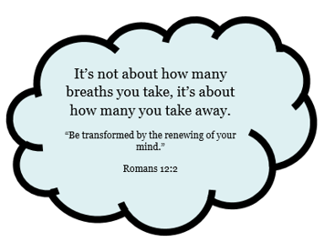


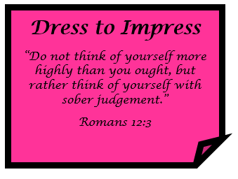


Science Subject Policy

- Intent
The 2014 national curriculum for science aims to ensure that all pupils:
- Develop scientific knowledge and conceptual understanding through the specific disciplines of biology, chemistry and physics
- Develop understanding of the nature, processes and methods of science through different types of science enquiries that help them to answer scientific questions about the world around them
- Are equipped with the scientific knowledge required to understand the uses and implications of science, today and for the future.
At Queens C of E Academy, we believe that all our children deserve the best and our aim is to help them reach their potential in every area of school life. We follow the aims of the 2014 Primary National Curriculum for Science by focusing on developing pupils' scientific knowledge and conceptual understanding in Biology, Chemistry, and Physics. Through this curriculum, pupils are equipped with the skills needed to ask questions, plan investigations, observe, record, and evaluate results. These skills are developed through the five types of scientific enquiry: observing over time, pattern seeking, identifying, classifying and grouping, comparative and fair testing, and researching using secondary sources.
Each year group also studies a supplementary topic focused on Earth and environmental changes. This focus helps pupils understand the challenges facing the planet and encourages them to adopt sustainable practices. We endeavour to make learning a positive experience which will stay with the children long after they have left Queens Academy and help shape their future. Our science curriculum will enable all children to explore and discover the world around them and beyond their everyday experience, creating citizens who make positive contributions to the future of our planet. We teach Science in a way that inspires our children to be innovative, independent and imaginative, with the hope that they will foster a life-long love for the subject.

- Implementation
The 2014 National Curriculum provides the basis for our Science curriculum at Queens C of E Academy. This is supplemented by an additional unit of work as selected by the Science Subject Leader to help promote our curriculum drivers of aspiration, respect and opportunity as well as encouraging pupils to be global citizens. Science topics have been organised in such a way that the acquisition of knowledge and skills is progressive as children work their way through both each year group and the key stage. Children are also encouraged to make wider links to their curriculum topics and the overarching 3 areas of science: chemistry, biology and physics.
Pupils develop their working scientifically skills by engaging with the five types of scientific enquiry. Investigations and experiments are conducted regularly, giving pupils hands-on opportunities to practice planning, observing, measuring, recording, and evaluating their findings.
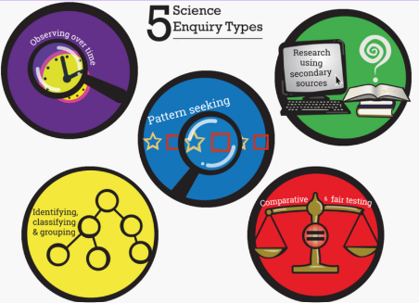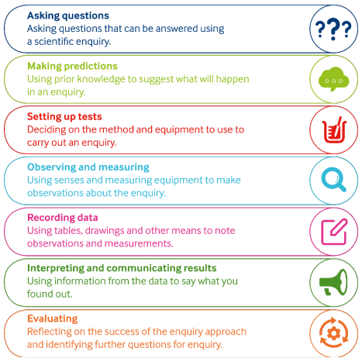

The Science subject leader has developed a detailed medium-term plan that supports the delivery of high-quality Science teaching. This plan clearly outlines the specific National Curriculum aims being met in each lesson, ensuring that the statutory requirements are fulfilled. Additionally, the medium-term plan specifies which types of scientific enquiry are being covered, highlights the scientific skills being developed, and identifies the primary focus for each lesson. This structured approach ensures consistency and progression across year groups and helps teachers deliver lessons with clarity and confidence.
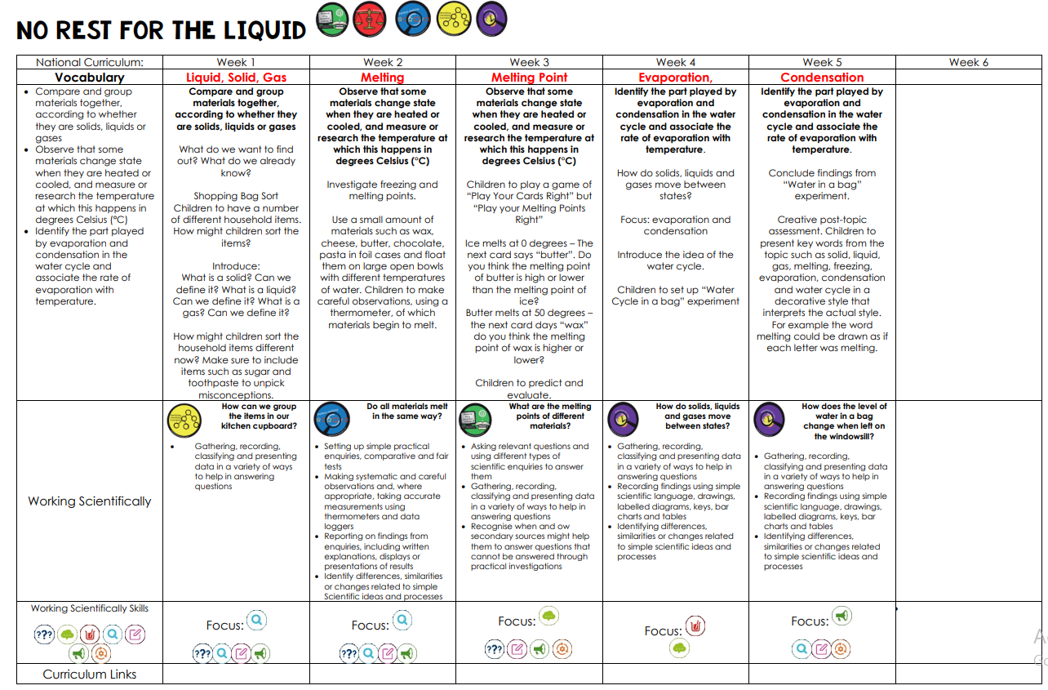
Vocabulary development is a key element of our curriculum. At the beginning of each topic, pupils assess their understanding of key scientific terms using the RAG system. These terms are explicitly taught at the beginning of each lesson and pupils are encouraged to apply their own understanding of the key terms by putting them into their own sentence. At the end of the topic, pupils reassess their understanding of the vocabulary, allowing them to reflect on their progress.
Each Science unit is focused on answering a “Big Question” to support children’s intellectual curiosity. Through answering these questions are the end of each topic, pupils are not only encouraged to consolidate their learning but also helps them understand the relevance of Science in their lives.
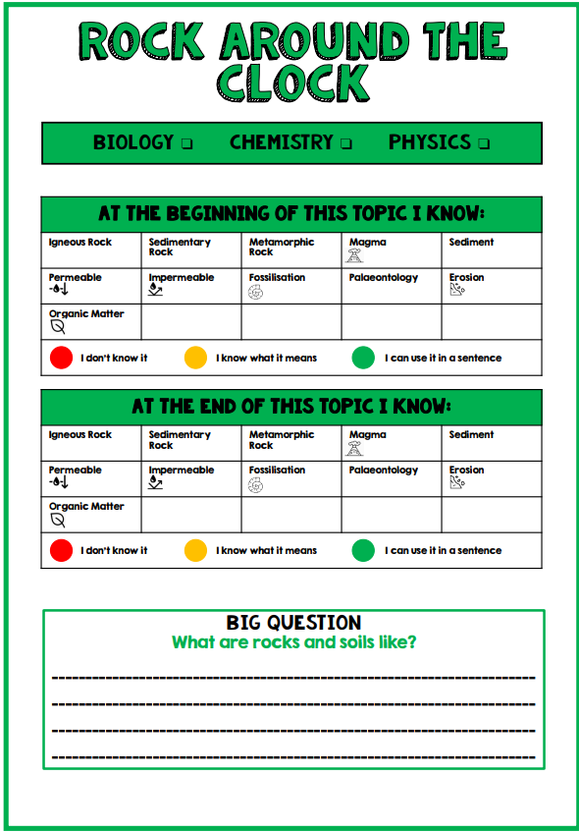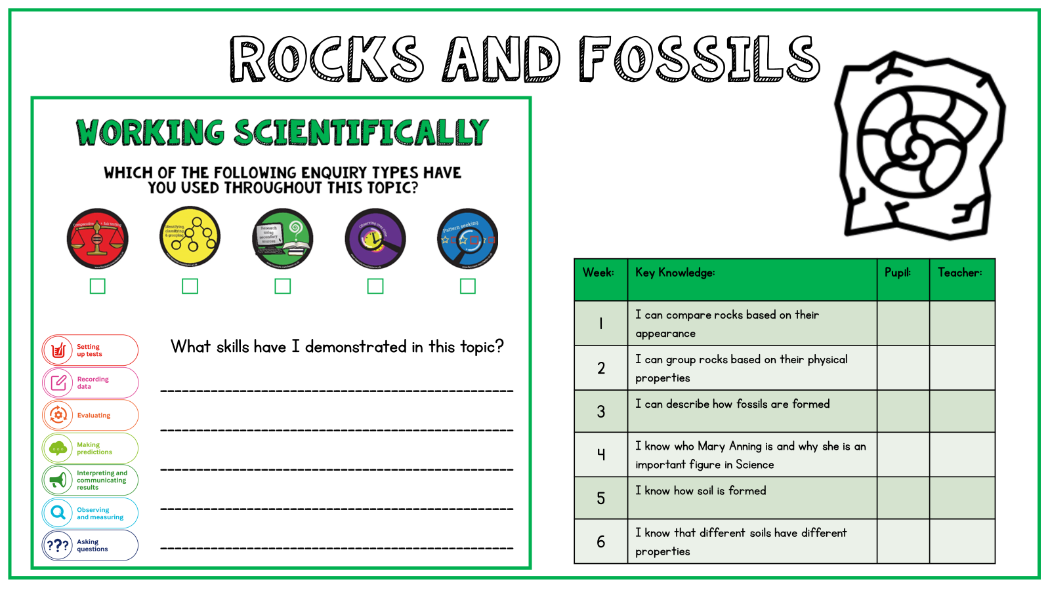
We use inclusive practices to ensure that all pupils can access the curriculum. Differentiated support is provided for pupils with SEND or EAL, while opportunities for challenge and extension are offered to stretch high-attaining pupils. Assessment is ongoing throughout each topic including observations, questioning and marking of work. Both teachers and pupils are encouraged to RAG rate understanding of the key learning for each lesson. Summative assessments, including vocabulary reassessment, responses to Big Questions, and pupils’ reflection on their application of working scientifically skills measure pupils’ progress and inform future planning.

- Impact
The subject leader monitors the impact of the taught curriculum through learning walks, work trawls, pupil interviews and staff discussions. This monitoring is recorded termly on Subject Snapshots, which are shared with SLT. Feedback is given to staff, including individual or year-group feedback as appropriate. The findings feed into annual Subject Status Reports, which are used to identify key priorities for the subject, including changes to Long Term Plan, as part of the SIDP.
The impact of our Science curriculum is evident in the knowledge, skills, and enthusiasm that pupils develop over time. Pupils gain a secure understanding of key scientific concepts and vocabulary in Biology, Chemistry, and Physics. They become proficient in working scientifically, confidently using the five types of scientific enquiry to investigate questions and solve problems.
Progress is visible through pupils’ vocabulary assessments, their ability to answer Big Questions, and their overall attainment in Science. Summative assessments and teacher observations highlight that pupils are achieving well and developing a deep understanding of scientific concepts.
By making connections between Science and its real-world applications, pupils are well-prepared for the next stage of their education and for life beyond school. The environmental focus of our curriculum helps pupils understand the importance of sustainable practices and equips them with the skills to address global challenges.
Pupils are enthusiastic about Science, engaging actively in hands-on investigations and making meaningful links across the curriculum. Reflection activities at the end of each topic foster a sense of achievement and encourage critical thinking.
Finally, pupils leave Queens CofE Academy as informed, responsible citizens who understand the importance of caring for the planet and making sustainable choices. They are well-equipped to make a positive and lasting impact on the world, carrying forward the knowledge and skills they have developed during their time at our school.

