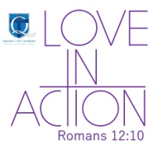
Queens Church of England Academy
Learning and Growing
in the Love of God

British Values Policy

Adopted by the Leadership team January 2026
Approved by full Governing Body

Signed by Chair of Governors Paul Allred

To be reviewed January 2028
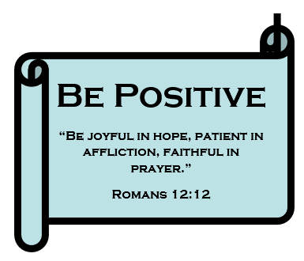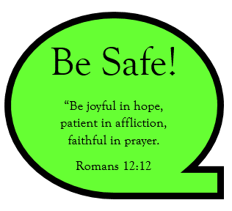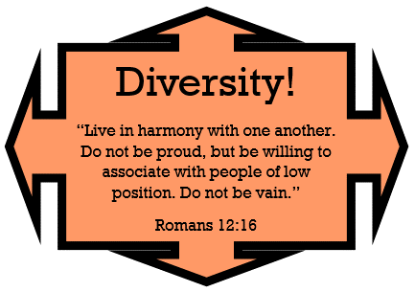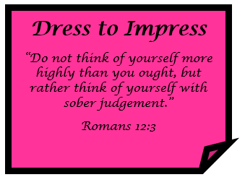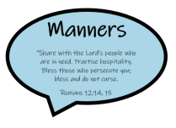





“Whatever you do, work at it with all your heart, as if working for the Lord and not for human masters” – Colossians 3:23

“The heavens declare the glory of God; the skies proclaim the work of His hands.” – Psalm 19:1

“We want every school to promote the basic British Values of democracy, the rule of law, individual liberty, and mutual respect and tolerance for those of different faiths and beliefs.” (Lord Nash, 2014)

Introduction:

At Queens C of E Academy, we want our children immersed in a culture which upholds and explicitly teaches and reinforces these values.

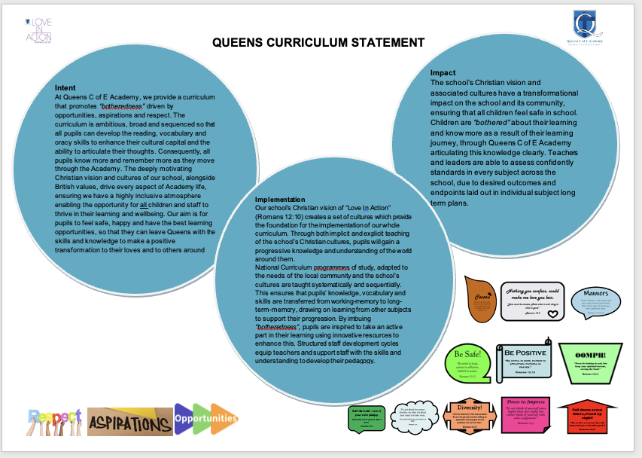

Our inspirations which helped us to create and shape our ambitious curriculum are: aspirations, opportunities and respect. We provide our children with carefully structured sequences of learning in all subject areas, which encourage them to aspire to be whatever they want to be, giving them opportunities to study ancient and modern Britain, whilst maintaining a respect for themselves, others and our world. We want our children to leave us as valuable and fully rounded citizens, prepared for life in modern Britain.

The British Values are:
- Rule of Law
- Democracy
- Individual Liberty
- Tolerance
- Mutual Respect

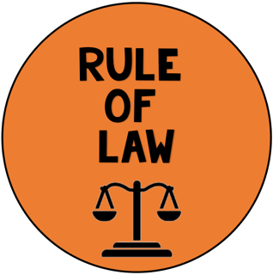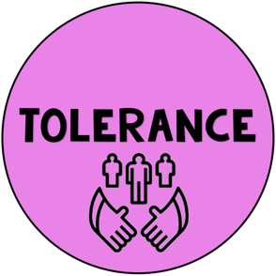

*This policy should be read in conjunction with our Curriculum Policy, our Teaching and Learning policy and our “British Values across the Curriculum” document.

Our school logo includes the phrase “Love In Action” which is taken from Romans 12:10 and everything we say, do and teach at Queens is based around this. As a C of E Academy, we encourage our children to think about the life Jesus led and what he taught us about how we should behave. Whatever we do, we encourage the children to consider “Am I showing Love In Action here?”

We have a selection of cultures, which we continually refer to, and include:


Having the right to time alone in a safe space.
INDIVIDUAL LIBERTY

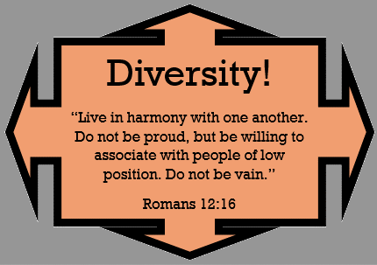
Embracing and celebrating our diverse culture within our school.
TOLERANCE AND
MUTUAL RESPECT

 and 
Encouraging the children to be honest at all times, even if they feel a little afraid to do so.
RULE OF LAW AND INDIVIDUAL LIBERTY

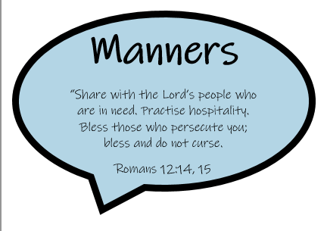
Politeness and respect to all.
RULE OF LAW AND MUTUAL RESPECT

What we do in school (some but not all!)

- Learn about Britain and its people in History, Geography and Religious Education
- Encourage oracy so that all pupils have a voice, in all subjects, with school ambassadors who can speak on behalf of others
- Rules of: Ready, Safe, Respect at all times, inside and outside the classroom, lining up, studying different religions, sharing resources
- Respecting each other: through work on display and celebration assemblies.

*See also Curriculum policy and Teaching & Learning policy and British Values across the curriculum doc.

