
Queens C of E Academy
Year 3
Art and Design Challenges

AUTUMN ART HOMEWORK CHALLENGE 1
The Renaissance
(Leonardo da Vinci)

The Mona Lisa is one of the most famous painting from the Renaissance times.

Can you create your own image of the Mona Lisa using coloured squares?

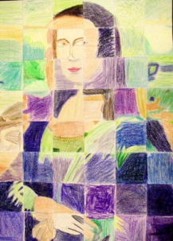
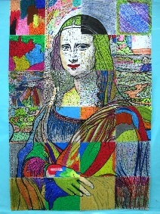

AUTUMN ART HOMEWORK CHALLENGE 2
The Renaissance
(Leonardo da Vinci)

Da Vinci was famous for his inventions.
Can you draw and label your own imaginative invention? For example: lying machines, robot pets, water-powered gadgets, etc.
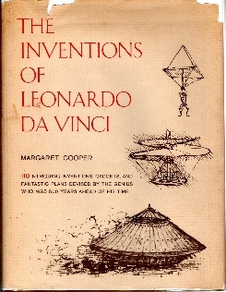
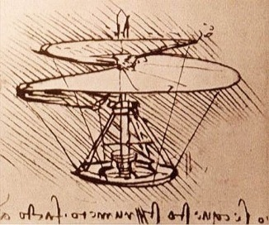

Queens C of E Academy
Year 3
Art and Design Challenges

SPRING ART HOMEWORK CHALLENGE 1
Impressionism
(Pierre-Auguste Renoir)

Can you recreate this famous Renoir painting (“Luncheon shapes of the boating party”, 1881) in your own way? Photograph family and friends in the same poses? Trace it and colour? Pencil drawing? Some kind of mosaic? Anything goes!!
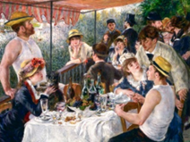

SPRING ART HOMEWORK CHALLENGE 2
Impressionism
(Pierre-Auguste Renoir)

Impressionists like to go outside to sketch something they see: a garden, a tree, a building, etc.
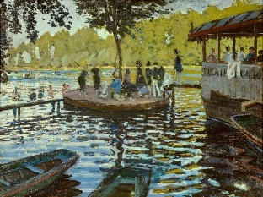
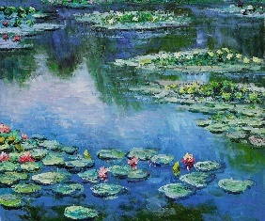
Use your observational skills to choose something you would like to draw from the environment around you. Use dots and short strokes to present your artwork in the styles of the Impressionism.

Queens C of E Academy
Year 3
Art and Design Challenges

SUMMER ART HOMEWORK CHALLENGE 1
Abstract Art
(Wassily Kandinsky)

Can you create your own image in the style of this famous artist?

Divide your paper into 12 sections and draw some shapes (they do not have to be circles – perhaps squares or triangles, or even hexagons?). Colour the shapes in different colours and add a background colour for each section too. You can use whatever medium you like!
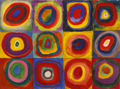

SUMMER ART HOMEWORK CHALLENGE 2
Abstract Art
(Wassily Kandinsky)

Wassily Kandinsky produced his art pieces whilst listening to music.
Can you use only (triangles, circles, squares, zigzags, swirls) to make a bold, abstract composition, like a shape symphony? You should try to balance the space like a visual “song.”


