
Queens C of E Academy
Year 4
Art and Design Challenges

AUTUMN ART HOMEWORK CHALLENGE 1

All Work and no Play
(LS Lowry)

Could you produce a piece of artwork in the style of Lowry?
You could copy this image, or perhaps take a photograph of a street near you and add in the stick people? Or even find an image of a British street on the internet and use that? You can choose whichever medium you like!
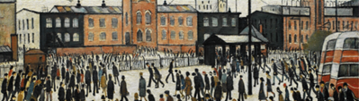

AUTUMN ART HOMEWORK CHALLENGE 2
All Work and no Play
(LS Lowry)

Draw a two-part story showing a group of people working in one half of the page and then playing or relaxing in the other (e.g. at the park or seaside).
Use a visual contrast by showing a balance in work/life, as an art narrative.


Queens C of E Academy
Year 4
Art and Design Challenges

SPRING ART HOMEWORK CHALLENGE 1
Cityscape Art
(Camille Pissaro)

This painting is of Hyde Park in London and was painted by Pissaro in 1880.

Try to recreate this image using coloured pencils perhaps or any other medium you would like.
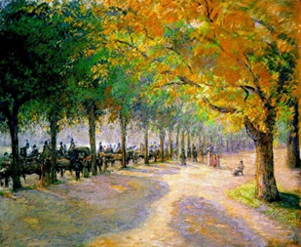

SPRING ART HOMEWORK CHALLENGE 2
Cityscape Art
(Camille Pissaro)

Design Your Own Imagined Cityscape, inspired by Pissarro’s city views — including buildings, roads, people, and transport. Try to use depth and perspective in an urban layout and maybe include human activity.
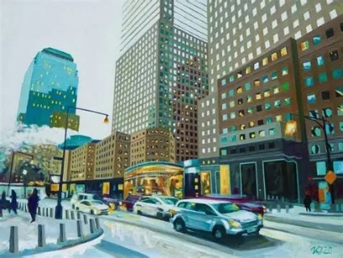

Queens C of E Academy
Year 4
Art and Design Challenges

SUMMER ART HOMEWORK CHALLENGE 1
Royalty
(Hans Holbein the Younger)

Holbein famously painted many portraits of the Tudors like this one below of Henry VIII. See how many different images of Holbein’s Tudor portraits you can find and make a collage with them.

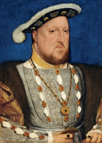
SUMMER ART HOMEWORK CHALLENGE 2
Royalty
(El Greco)

Create a royal portrait (king, queen, prince, or noble) in the elongated, expressive style of El Greco — long faces, dramatic hands, and flowing robes.
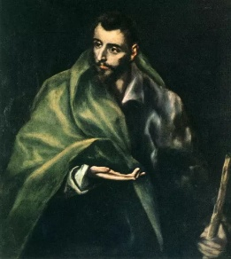
Show portraiture proportion, with an expression of exaggeration.

