
Queens C of E Academy
Year 5
Art and Design Challenges

AUTUMN ART HOMEWORK CHALLENGE 1
Cultural Tradition in Art
(Richard Kimbo)

Draw a scene from daily life in a traditional village, showing people working together — e.g. cooking, farming, building, or preparing for a festival — inspired by Richard Kimbo’s warm, community-focused batik paintings.

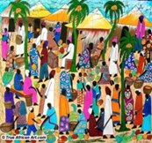
AUTUMN ART HOMEWORK CHALLENGE 2
Cultural Tradition in Art
(Richard Kimbo)

Design traditional clothing with bright colours and bold patterns, inspired by the vibrant clothes seen in African art. You could dress a drawn figure (or cut-out template) in your own fabric design.



Queens C of E Academy
Year 5
Art and Design Challenges

SPRING ART HOMEWORK CHALLENGE 1
Amazed by Architecture
(Zaha Hadid)

Invent and draw your own dream building, inspired by Zaha Hadid’s futuristic, flowing designs — maybe a curved school, a flying library, or a wavy home!
Label the parts of the building and describe what it's used for, whilst exploring
shape, scale, and space.
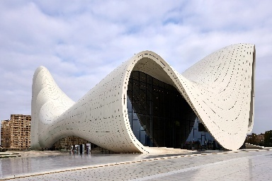

SPRING ART HOMEWORK CHALLENGE 2
Amazed by Architecture
(Zaha Hadid)

Draw or paint a futuristic city filled with creative buildings, flying walkways, flowing bridges, and eco features — a city that’s exciting, beautiful, and kind to the planet.


Queens C of E Academy
Year 5
Art and Design Challenges

SUMMER ART HOMEWORK CHALLENGE 1
Exploring Expressionism
(Henri Matisse)

Inspired by Matisse’s famous cut-out works (like The Snail or Icarus), use coloured paper (or recycled materials) to cut and arrange bold, organic shapes into an expressive composition. Remember to use your collage techniques and simplify your shapes.

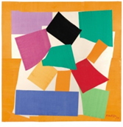
SUMMER ART HOMEWORK CHALLENGE 2
Exploring Expressionism
(Henri Matisse)

Choose a simple object from everyday life (like a flower, chair, bowl, or animal) and re-draw it in an Expressionist or Matisse-inspired style — with bold outlines, simplified forms, and vivid colours.


