
Queens C of E Academy
Year 6
Art and Design Challenges

AUTUMN ART HOMEWORK CHALLENGE 1
Futurism
(Umberto Boccioni)

Futuristic Cityscape.
Draw a city of the future, filled with flying transport, moving lights, spinning energy sources — using sharp, dynamic angles and bold, expressive colours.
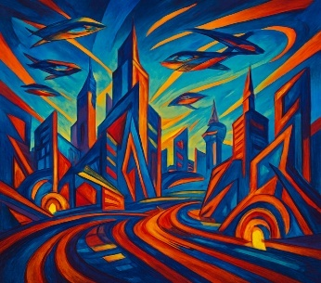

AUTUMN ART HOMEWORK CHALLENGE 2
Futurism
(Umberto Boccioni)

Draw a person or animal in motion, inspired by Balla’s “Dynamism of a Dog on a Leash” or Boccioni’s “Unique Forms of Continuity in Space”. Show repetition, blurred lines, or overlapping shapes to create the illusion of speed. As you capture motion in art.
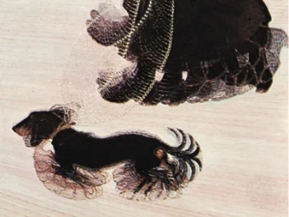
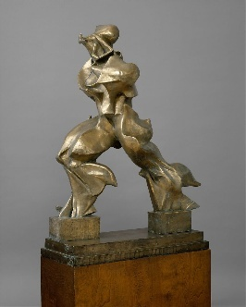

Queens C of E Academy
Year 6
Art and Design Challenges

SPRING ART HOMEWORK CHALLENGE 1
Cultural Tradition in Art
(Henri Rousseau)

This painting by Rousseau is called “Tiger in a tropical storm”. Can you do your own painting / drawing of an animal hiding in a jungle or forest? Use whatever medium you would like, add colour if you wish (but you don’t have to) and don’t forget to give it a name! See if your teacher can spot the hidden creature!
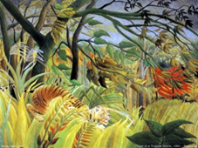
SPRING ART HOMEWORK CHALLENGE 2
Cultural Tradition in Art
(Henri Rousseau)

Invent a mythical or symbolic animal from your own or another culture (e.g. dragon, phoenix, leopard, jaguar) and place it in a magical jungle scene like Rousseau’s, surrounded by traditional objects or plants.
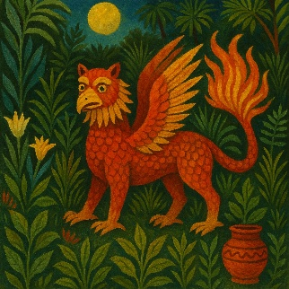

Queens C of E Academy
Year 6
Art and Design Challenges

AUTUMN ART HOMEWORK CHALLENGE 1
Art and Fashion
(Piet Mondrian)

Design your own T-shirt using Mondrian’s famous colour-block style (bold lines, primary colours, and rectangles). You can draw your design on a T-shirt outline and colour it in.
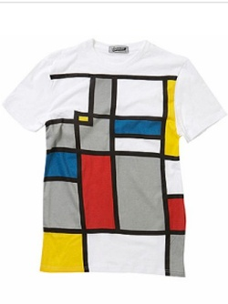
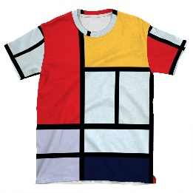
AUTUMN ART HOMEWORK CHALLENGE 2
Art and Fashion
(Piet Mondrian)

Draw and colour 3 fashion items (e.g. a dress, shoes, handbag, or sunglasses) using only geometric shapes (squares, circles, triangles) and patterns in the spirit of abstract art.


