

Queens Church of England Academy

Design and Technology Policy

Adopted by the Leadership team March 2025

Approved by full Governing Body March 2025

To be reviewed March 2027

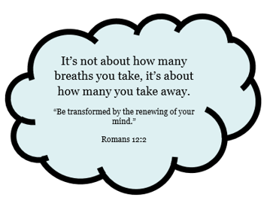


Design And Technology is all around us. We see it every day and it is an important part of our lives. We need it to live, learn, play, protect and improve the world we live in. Design and Technology allows children to become problem solvers, innovative thinkers, critics, analysers, creative workers, empathetic to their surroundings and others; the list could go on…More importantly, it opens the door of possibilities for their and our future.

Intent
Design and Technology allows the children to discover and think about the importance of the subject within the world, relating to real life problem solving, innovative ideas and giving an insight to the types of career options. By looking at existing technology, products and studying historical engineers and designers, children build on their knowledge of the subject. They are given the opportunity to explore the subject by completing a range of projects and building their skills as they move through the school. By studying key individuals or looking at careers within the subject, aspirations are raised and children are inspired to pursue Design and Technology and respect the importance and relevance it has in our lives and the world around them.
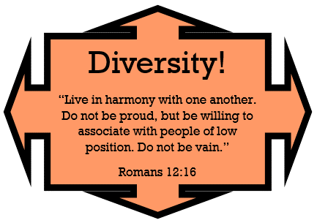


Implementation

The principal aim is to develop children’s knowledge, skills and understanding in Design and Technology. A variety of teaching and learning styles are used and teachers ensure that the children apply their knowledge and understanding when developing ideas, planning and making products, and then evaluating them. Children complete projects each term, held over two days, using a subject unit or topic as a stimulus, this allows the children to use information and ideas already gathered to incorporate and influence their work. Through teacher modelling and investigation, we teach specific skills and techniques within each project as well as skills that help develop children’s analytical and creative thinking. These are built upon each year; applying what they have already learnt in new projects will further embed them, and improving and refining those skills will produce well thought out products. Children are given the opportunity to collaborate on design briefs, sharing ideas and discussing the rationale behind their design and respecting others’ opinions. Children evaluate and persevere in their work and learn that failure is a chance to redo and improve, not give up. They also look at and evaluate existing products through research, and complete focussed tasks; learning and understanding the basic skills needed before implementing it into a real product. ICT is used to research, present and in CAD.
Inclusion
In all classes, there are children of differing ability. We recognise this fact and provide suitable learning opportunities for all children. We achieve this through a range of strategies:
- setting common tasks that are open-ended and can have a variety of results;
- working in mixed ability grouping;
- providing a range of challenges through the provision of different resources;
- providing scaffold and visual word banks;
- modelling and focussed tasks;
- using additional adults to support the work of individual children or small groups.

Impact
Teachers and leaders are able to assess standards in Design and Technology across the year due to our newly developed assessment systems. Milestone checklists are used to ensure a balanced coverage and make assessment judgements of pupil progress. Children’s work is recorded in books through written and photographical evidence and follows them through school to allow subject lead to see their learning journey across the key stage.

Curriculum
Design and Technology has four main areas of focus:
Design
- use research and develop design criteria to inform the design of innovative, functional, appealing products that are fit for purpose, aimed at particular individuals or groups
- generate, develop, model and communicate their ideas through discussion, annotated sketches, cross-sectional and exploded diagrams, prototypes, pattern pieces and computer-aided design
Make
- select from and use a wider range of tools and equipment to perform practical tasks [for example, cutting, shaping, joining and finishing], accurately
- select from and use a wider range of materials and components, including construction materials, textiles and ingredients, according to their functional properties and aesthetic qualities
Evaluate
- investigate and analyse a range of existing products
- evaluate their ideas and products against their own design criteria and consider the views of others to improve their work
- understand how key events and individuals in design and technology have helped shape the world
Technical knowledge
- apply their understanding of how to strengthen, stiffen and reinforce more complex structures
- understand and use mechanical systems in their products [for example, gears, pulleys, cams, levers and linkages]
- understand and use electrical systems in their products [for example, series circuits incorporating switches, bulbs, buzzers and motors]
- apply their understanding of computing to program, monitor and control their products.
- Join textiles with appropriate stitching, Select the most appropriate techniques to decorate textiles
Cooking also comes under technical knowledge:
- understand and apply the principles of a healthy and varied diet
- prepare and cook a variety of predominantly savoury dishes using a range of cooking techniques
- understand seasonality, and know where and how a variety of ingredients are grown, reared, caught and processed.
The planning uses the Chris Quigley Curriculum Companion subject checklists and the National Curriculum for key skills that need to be taught. Children will cover these areas across the year through a variety of ways. Projects tie into current subjects that the children are learning; in particular, Science and Mathematics where STEM activities are included and encouraged to provide cross-curricular links, skill utilisation and context, further embedding those skills and knowledge. Focussed tasks help understand and research key skills, so that they can be applied to a project. The impact of Design and Technology is evaluated through assessment for learning throughout the year and at the end of each project. By looking at examples of children’s work and pupil interviews in each year group, the Subject leader can see where the skill has been taught and the progression from LKS to UKS.
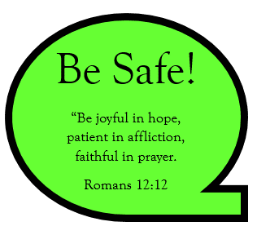
Health and Safety
Children are taught the importance of safety within Design and Technology. Teachers model how to use equipment safely and children are monitored when using it.
The safety of the children is the responsibility of the class teacher. All staff must complete a risk assessment on materials being used/lessons being taught.

