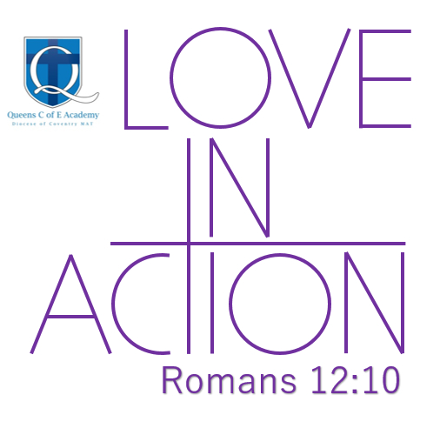
PESSPA (PHYSICAL EDUCATION, SCHOOL SPORT
AND PHYSICAL ACTIVITY) AT QUEENS
WHAT IS THE QUESTION RELATING TO? | WHAT HAVE WE DONE? | WHAT DOCUMENTATION COULD WE SHOW?
THE DESIGN: | Starting with the National Curriculum and through careful consideration of planning:  ‘’The basis and aim of our curriculum will be around learning and applying practical skills in order to participate, compete and lead a healthier lifestyle. Children will learn to develop their own physical capabilities and gain a better understanding of their own health and mental well-being, on which we depend, as well as showing a greater focus on encouraging to feel. Through Physical Education, School Sport and Physical Activity (PESSPA), children will also develop further their knowledge of our Christian Cultures and practice them in a safe environment in their quest of becoming great sports people.”  We aim to provide a curriculum which will support the overall aims and ethos of the school and that develops the knowledge, skills, attitudes, and beliefs that enable pupils to respond to the physical challenges of every day through for example, skilfulness, decision making, physical condition, health and mental wellbeing and attitudes.  Thought carefully about “What makes a good Sportsperson?” (see policy and guidance).  Opportunities:  - PE (weekly)  - Sports Day (annual)  - Inter-House events (termly)  - Extra-Curricular activities: After-School Sports Clubs (weekly) | - Subject Overview and Long-Term Mapping  - Subject Policy & Guidance  - Subject Status Form  - Cross curricular doc  - Where / where / when doc  - British Values across the curriculum
THE KNOWLEDGE: | Across individual topics, children are taught learning themes related to the concepts of each sport/game. In design, this includes opportunities for children to articulate their knowledge surrounding learning themes, retrieval, and vocab (themes) recap. Created and links to progression of skills document. | - Subject Overview and Long-Term Mapping  - Progression of Skills  - Evidence from pupil voice
THE B.O.L.T. | Looked carefully at what has been taught before and how a current topic builds on this (including contact with our feeder schools). Then looking ahead at what this leads into (including contact with our secondary schools and their curriculum coverage). | - B.O.L.T (Long-Term Overview).  - Infant and Secondary Curriculum Maps
LITERACY ACROSS THE CURRICULUM: | Opportunities for oracy in all units – paired work, small group work, feedback and analysis | - Examples of pupil voice and what the children have said
THE ANALYSIS: | Every time subject lead does monitoring, there is a Snapshot Form completed. These are evidence of pupil voices, book trawls, lesson observations. Findings then feed into the Subject Status Form (SSF) which is created at the beginning of an academic year and then updated at the end of each term. Key points are fed into the Curriculum Status Form and then into the whole school SIDP. When data drops happen, this gives subject lead an opportunity to analyse standards in their subject and consider areas for development moving the subject and its delivery forward. | - Examples of Snapshot forms  - Most recent Subject Status Form  - INSIGHT data examples and findings.  Prove there is a “so what?”

OUR CURRICULUM AT QUEENS IS FAIRE: (the verb “faire” in French, means to make or do)
- Flexible
- Ambitious
- Inclusive
- Relevant
- Excellent



