

Queens Church of England Academy

History Policy

Adopted by the Leadership team February 2026

Approved by full Governing Body 2026

To be reviewed February 2028
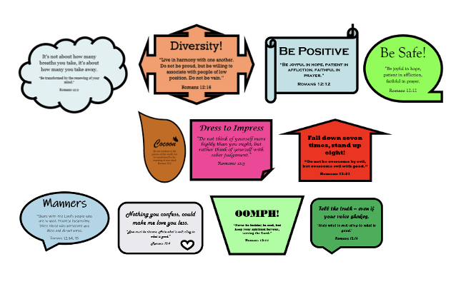
Curriculum Intent
We aim to provide a History curriculum that is inclusive, challenging and engaging. A broad knowledge of the history of Britain and the wider world makes a significant contribution to children’s cultural capital, which is an essential element in raising aspiration and opportunity. We teach British history chronologically to ensure pupils’ understanding of change over time. We ensure this is embedded, so that pupils can draw on their prior knowledge to make links between units studied. By focusing on local landmarks that either have a national significance or reflect national and international developments, pupils will extend their knowledge beyond 1066, and develop the empathy skills that are fundamental to historical understanding. In order to broaden pupils’ horizons and foster respect for other cultures, pupils will study aspects of world history parallel to the areas of British History that they have learned about.
In order to develop as historians, pupils will be taught to use a range of historical skills, outlined in the National Curriculum programmes of study. These are shared with the pupils as ‘what makes a great Historian?’ so that they are able to understand and articulate their own learning in this subject.
Implementation
The National Curriculum provides the basis for History Planning. It is supported by the Curriculum Companions scheme (Chris Quigley), which has been adapted to meet the bespoke needs of our pupils. Using the approach adopted by Hywel Roberts (English and drama teacher, storyteller, author and coach), each unit begins with a ‘Let’s say…’ narrative to draw the pupils into an engaging and purposeful story, on which the content of the unit is built upon.
Each History unit is focused on answering a ‘Big Question’ to engage pupils’ interest and prompt lines of enquiry. At the start of each unit, pupils are given a knowledge summariser, with relevant timelines and images of key individuals or artefacts to provide contextual clues. A large-scale timeline on the School Playground is used to develop pupils’ knowledge of where their current History topic sits in ‘the Big Picture’. However, as History is an enquiry-based subject, pupils are expected to build their own banks of knowledge as the topic progresses. A key vocabulary sheet is reviewed by children at the start of the topic and is revisited at the end, to determine how their knowledge of key vocabulary has improved and how they are able to use this in the context of the history topic.
History is taught for 75 minutes per week, and is shared equally across the year with Geography. Year Group teams plan sequences of lessons, using the Long-Term Plan for guidance. At this stage, teachers will decide on how best to integrate drama and storytelling to develop empathy, as well as visits to local areas of historical interest in order to explore a wider range of sources than those available within the School. Technology, including the Immersive Classroom, is used to further increase the availability of sources from further afield.
Impact
Using the Insight online assessment tool, class teachers assess pupils’ attainment using a range of informal strategies, including marking and verbal feedback. Although high-quality written work is valued, in order to provide a holistic assessment of pupils’ attainment, responses may also include drawings, models or spoken explanations that demonstrate historical knowledge and understanding. Children complete a key knowledge statement at the end of each lesson with a rating of their understanding, and the teacher also completes this. This is shown on the unit front cover and can therefore be easily monitored by the subject leader.

The subject leader monitors the impact of the taught curriculum through learning walks, work trawls, pupil interviews and staff discussions. This monitoring is recorded termly on Subject Snapshots, which are shared with SLT. Feedback is given to staff, including individual or year-group feedback as appropriate. The findings feed into annual Subject Status Reports, which are used to identify key priorities for the subject, including changes to Long Term Plan, as part of the SIDP.

