THRESHOLD CONCEPTS:
PERFORMING, COMPOSING, LISTENING, THE HISTORY OF MUSIC.
INTER-RELATED DIMENSIONS OF MUSIC: PITCH, DURATION, DYNAMICS, TEMPO, TEXTURE, STRUCTURE, TIMBRE, APPROPRIATE MUSICAL NOTATION
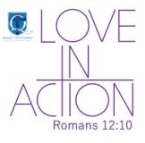
SUBJECT LEADER: Beth Bradshaw
PLANNING COMES FROM: KAPOW! 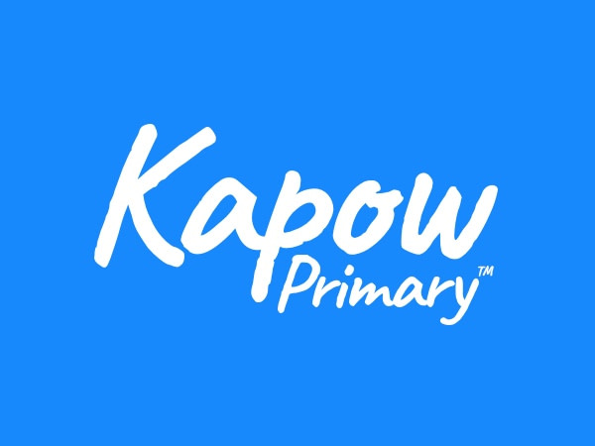

Whole School Overview
MUSIC

KAPOW! scheme purchased Autumn 2024 – this is taught weekly. There are also opportunities for the children to sing with an ongoing school choir and Young Voices, and throughout the Christian festivals celebrated during the year: Christmas, Easter, End of Y6 production- this takes over some units (see below)

Year Group | Autumn 1 | Autumn 2 | Spring 1 |  | Spring 2 | Summer 1 | Summer 2
YEAR 3 | MAP MAKERS!  Ballads | ADVENTURES OF EARLY MAN  Creating compositions in response to animation (mountains) | TOMB RAIDERS  Pentatonic melodies and composition (Chinese New Year) | LOCATION, LOCATION, LOCATION  Easter service |  | FOOD, GLORIOUS FOOD!  Jazz | ROME AND AWAY!  Traditional instruments and improvisation  (India)
YEAR 4 | THE EARTH STRIKES BACK! | ANGLES AND ANGELS | DRAGON SLAYERS |  | SHOULD WE SAVE THE RAINFOREST? | WHAT REALLY HAPPENED AT THE BATTLE OF BOSWORTH? | TALES FROM THE RIVERBANK
YEAR 4 | The Hub – teach cornet (or other instrument) lessons to all 3 classes over the year - 2 classes per term whilst the other follows KAPOW!
YEAR 4 | The 2 units from KAPOW! covered are:  Samba and carnival sounds (South America)  Body and tuned percussion (Rainforests)
YEAR 5 | OH, I DO LIKE TO BE BESIDE THE SEASIDE!  Composition notation  (Ancient Egypt) | TOO MUCH OF A GOOD KING?  Christmas service | BRIGHT LIGHTS, BIG CITY  South and West Africa |  | THE MAYA: MASTERPIECE OR MAYA-HEM?  Composition to represent festival of colour  (Holi) | OCEAN COMMOTION!  Looping and remixing | CHILDREN OF THE REVOLUTION  Musical theatre
YEAR 6 | GREECE IS THE WORD!  Dynamics, pitch and texture  (Coast: Fingal’s Cave by Mendelssohn) | BIOMES AND CLIMATE ZONES 1  Songs of World War 2 | BIOMES AND CLIMATE ZONES 2  Film music | WITHOUT WAR-NING  Theme and variations (Pop Art) |  | BRITAIN GOES POP!  End of year performance songs | REGENERATION ROCKS!  End of year performance

