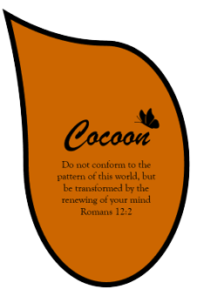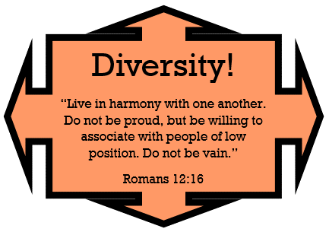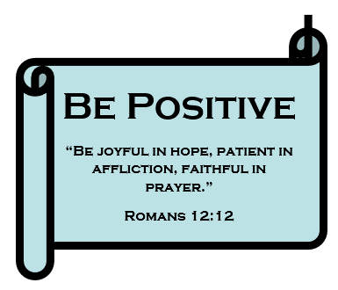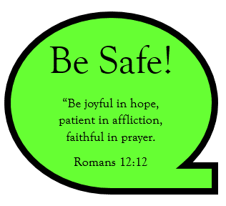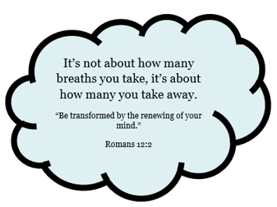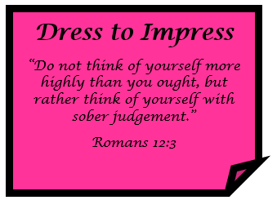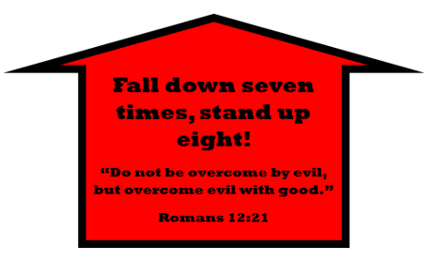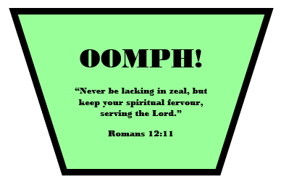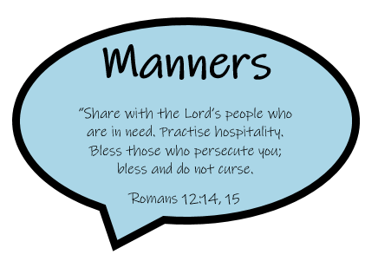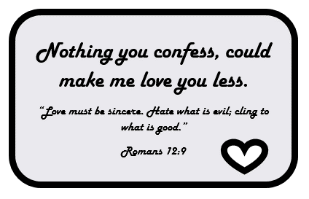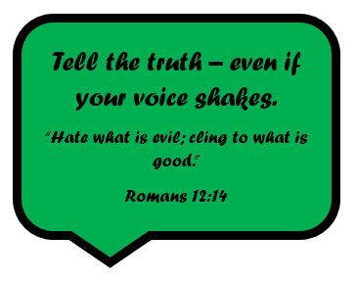

SUBJECT LEADER: Becky Dolman
PLANNING COMES FROM: 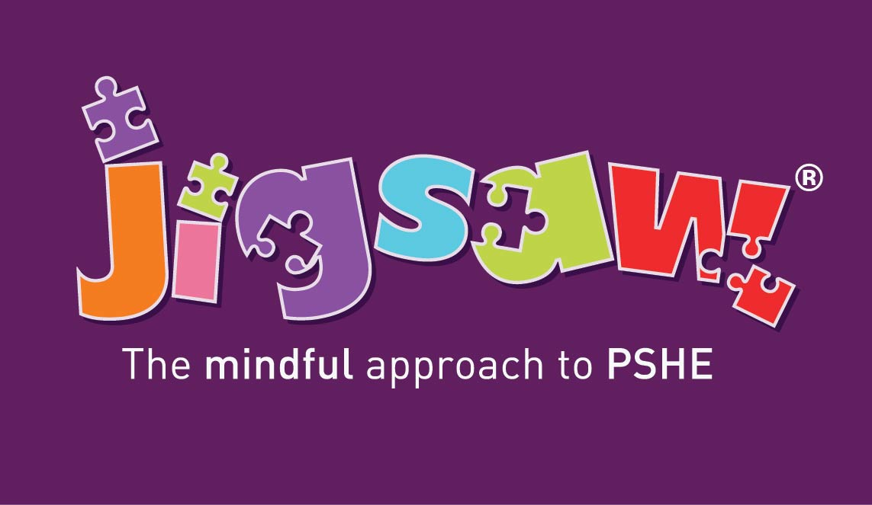
Whole School Overview
PSHE+C
Year Group | Autumn 1  BQ:  What are zones of regulation and how do I use them to help me manage my emotions? | Autumn 2  BQ:  Why do we like to belong? | Spring 1  BQ:  How can I overcome obstacles when working towards a goal? |  | Spring 2  BQ:  How do my choices affect my health? | Summer 1  BQ:  How can I build positive, healthy relationships? | Summer 2  BQ:  How can I cope positively with change?
YEAR 3 | MAP MAKERS! | ADVENTURES OF EARLY MAN | TOMB RAIDERS | LOCATION, LOCATION, LOCATION |  | FOOD, GLORIOUS FOOD! | ROME AND AWAY!
YEAR 3 | Key person  British values  ZONES OF REGULATION | Protective Behaviours  Remembrance  Celebrating Difference –  Respect for similarity and difference. Anti-bullying and being unique | Dreams and Goals – Aspirations, how to achieve goals and understanding the emotions that go with this. | Healthy Me –  Being and keeping safe and healthy |  | Relationships –  Building positive, healthy relationships | Changing Me –  Coping positively with change
YEAR 4 | THE EARTH STRIKES BACK! | ANGLES AND ANGELS | DRAGON SLAYERS |  | SHOULD WE SAVE THE RAINFOREST? | WHAT REALLY HAPPENED AT THE BATTLE OF BOSWORTH? | TALES FROM THE RIVERBANK
YEAR 4 | Key person  British values  ZONES OF REGULATION | Protective Behaviours  Remembrance  Celebrating Difference –  Respect for similarity and difference. Anti-bullying and being unique | Dreams and Goals – Aspirations, how to achieve goals and understanding the emotions that go with this. |  | Healthy Me –  Being and keeping safe and healthy | Relationships –  Building positive, healthy relationships | Changing Me –  Coping positively with change
YEAR 5 | OH, I DO LIKE TO BE BESIDE THE SEASIDE! | TOO MUCH OF A GOOD KING? | BRIGHT LIGHTS, BIG CITY |  | THE MAYA: MASTERPIECE OR MAYA-HEM? | OCEAN COMMOTION! | CHILDREN OF THE REVOLUTION
YEAR 5 | Key person  British values  ZONES OF REGULATION | Protective Behaviours  Remembrance  Celebrating Difference –  Respect for similarity and difference. Anti-bullying and being unique | Dreams and Goals – Aspirations, how to achieve goals and understanding the emotions that go with this. |  | Healthy Me –  Being and keeping safe and healthy | Relationships –  Building positive, healthy relationships | Changing Me –  Coping positively with change
YEAR 6 | GREECE IS THE WORD! | BIOMES AND CLIMATE ZONES 1 | BIOMES AND CLIMATE ZONES 2 | WITHOUT WAR-NING |  | BRITAIN GOES POP! | REGENERATION ROCKS!
YEAR 6 | Key person  British values  ZONES OF REGULATION | Protective Behaviours  Remembrance  Celebrating Difference –  Respect for similarity and difference. Anti-bullying and being unique | Dreams and Goals – Aspirations, how to achieve goals and understanding the emotions that go with this. | Healthy Me –  Being and keeping safe and healthy |  | Relationships –  Building positive, healthy relationships | Changing Me –  Coping positively with change

