CONCEPTS:
Belonging and Believing 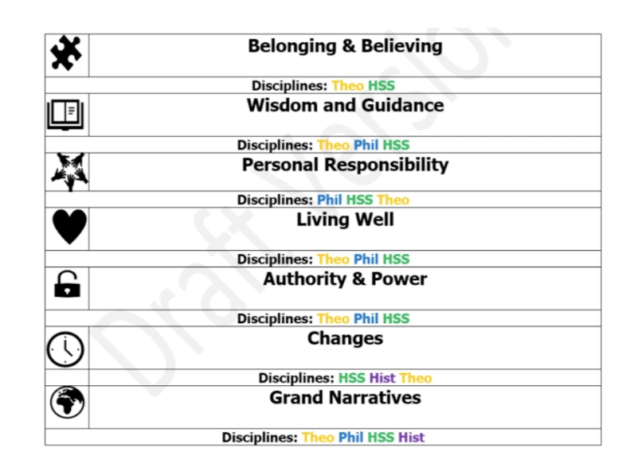
Wisdom and Guidance
Personal Responsibility
Living Well
Authority and Power
Changes
Grand Narratives
SUBJECT LEADER: Ryan Lapworth
PLANNING COMES FROM: Understanding Christianity/ Coventry and Warwickshire Agreed Syllabus (CWAS)


DISCIPLINES:
Theology (THEO)
Philosophy (PHIL)
Human and Social Science (HSS)
History (HIST)
Whole School Overview
RELIGION AND WORLDVIEW
Year Group | Autumn 1 | Autumn 2 | Spring 1 | Spring 2 | Summer 1 | Summer 2
ALL YEAR GROUPS
First lesson of the year:
What is worldview?
What are the disciplines and what do they mean?
(1 AFTERNOON)
YEAR 3 | MAP MAKERS! | ADVENTURES OF EARLY MAN | TOMB RAIDERS | LOCATION, LOCATION, LOCATION | FOOD, GLORIOUS FOOD! | ROME AND AWAY!
LAYOVER UNIT  FIRST | Islamic:  Enquiry questions:  - How do those with Muslim worldviews often demonstrate their beliefs? (masjid, prayer and service to humanity)  - What is so important about the Qur’an? (divine revelation and divine guidance)  (2 lessons)
THEN  ENQUIRY QUESTION (CWAS) | Why are nature and the seasons significant for religion and world views?  L2.1  (9 lessons) |  | How are world views shaped and expressed through art and architecture?  L2.2  (8 lessons) |  | What can world views tell us about conflict, peace, forgiveness and reconciliation and is that important?  L2.3  (10 lessons)
UNDERSTANDING CHRISTIANITY UNIT | UC 2A.3:  What is the trinity?  Incarnation / God  (1 day) |  | UC 2A.5  Why do Christians call the day Jesus died ‘Good’ Friday?  Salvation  (1 day) |  | UC 2A.1  What do Christians learn from the creation story?  Creation  (1 day)
YEAR 4 | THE EARTH STRIKES BACK!! | ANGLES AND ANGELS | DRAGON SLAYERS | SHOULD WE SAVE THE RAINFOREST? | WHAT REALLY HAPPENED AT THE BATTLE OF BOSWORTH? | TALES FROM THE RIVERBANK
LAYOVER UNIT  FIRST | Jewish:  Enquiry questions:  - Why are festivals so important for those with Jewish worldviews? (remembering)  - Why is it important to gather together as Jewish people? (synagogue)  - Why does following commandments matter in Jewish worldviews? (Mitvot)  (3 lessons)
ENQUIRY QUESTION  (CWAS) | How might your world view lead you to do hard things for good reasons?  L2.4  (10 lessons) |  | What or who is ‘God’ and how is the divine understood in theistic world views?  L2.5  (11 lessons) |  | Do you have to be part of a faith community to express an organised world view?  L2.6  (4 lessons) | How have religion and history entwined in this area?  L2.7  (5 lessons)
UNDERSTANDING CHRISTIANITY UNIT | UC 2A.3:  What is the trinity? (Digging deeper)  Incarnation / God  (1 day) |  | UC 2A.6  When Jesus left, what was the impact of Pentecost?  Kingdom of God  (1 day) |  | UC 2A.1  What do Christians learn from the creation story? (Digging deeper)  Creation  (1 day)

YEAR 5 | OH, I DO LIKE TO BE BESIDE THE SEASIDE! | TOO MUCH OF A GOOD KING? | BRIGHT LIGHTS, BIG CITY | THE MAYA: MASTREPIECE OR MAYA-HEM? | OCEAN COMMOTION! | CHILDREN OF THE REVOLUTION
LAYOVER UNIT  FIRST | Sikh:  Enquiry questions:  - What is unique about the Sikh understanding of God / supreme being? (Waheguru)  - Are all Sikhs the same? (Khalsa and non-affiliation)  - What is the significance of the gurdwara? (langar)  (3 lessons)
ENQUIRY QUESTION  (CWAS) | Why might ancient stories still be so important for some worldviews today?  U2.2  (10 lessons) |  | Do religions change or stay the same?  U2.3  (8 lessons) |  | What might it mean to ‘live well’?  U2.4  (9 lessons)
UNDERSTANDING CHRISTIANITY UNIT | UC 2B.4  Was Jesus the Messiah?  Incarnation  (1 day) |  | UC 2B.6  What did Jesus do to save human beings?  Salvation  (1 day) |  | UC 2B.2  Creation and Science: conflicting or complementary?  Creation / Fall  (1 day)

YEAR 6 | GREECE IS THE WORD! | BIOMES AND CLIMATE ZONES 1 | BIOMES AND CLIMATE ZONES 2 | WITHOUT WAR-NING | BRITAIN GOES POP! |  | REGENERATION ROCKS!
LAYOVER UNIT  FIRST | Jewish:  Enquiry questions:  - Why are festivals so important for those with Jewish worldviews? (remembering)  - Why is it important to gather together as Jewish people? (synagogue)  - Why does following commandments matter in Jewish worldviews? (Mitvot)  (3 lessons)
ENQUIRY QUESTION  (CWAS) | How do beliefs and ideas about land shape the way human beings live?  U2.5  (10 lessons) |  | How might your worldview impact on the way you understand death and beyond?  U2.6  (9 lessons) |  | What do organised worldviews have to tell us about truth and where it might be found?  U2.7  (10 lessons)
UNDERSTANDING CHRISTIANITY UNIT | UC 2B.8  What kind of king is Jesus?  Kingdom of God  (1 day) |  | UC 2B.7  What difference does the resurrection make to Christians?  Salvation  (1 day) |  |  | UC 2B.2  Creation and Science: conflicting or complementary? (Digging deeper)  Creation / Fall  (1 day)

