
Queens Church of England
Academy

Oracy Policy

Adopted by the Leadership Team February 2025

Approved by Governors March 2025

To be reviewed March 2027

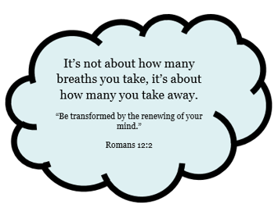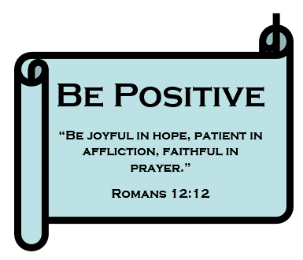

INTRODUCTION
At Queens C of E Academy, we believe that oracy—the ability to express oneself fluently and grammatically in speech—is a fundamental skill that underpins success in education and beyond. Oracy supports learning across the curriculum, enhances social interactions, and builds confidence in communication. Our vision is to provide a structured, progressive approach to oracy that empowers children to articulate their thoughts clearly, engage in meaningful discussions, and develop strong interpersonal skills.
We recognise that oracy is essential for:
- Life opportunities – Employers prioritise communication skills when hiring.
- Mental wellbeing – Children need to be able to express themselves confidently.
- Safeguarding – The ability to articulate thoughts helps children report concerns.
- Social development – Oracy supports friendships, collaboration, and teamwork.
- Academic progress – Research from the Education Endowment Foundation (EEF) highlights that strong oracy skills improve overall academic outcomes.
- Supporting disadvantaged and EAL pupils – Oracy helps bridge gaps in language acquisition and self-expression.
This policy outlines how we teach and develop oracy skills across the school, ensuring all children have the tools to communicate effectively.

Intent

Aims of Our Oracy Curriculum
At Queens Church of England Academy, we aim to:
- Embed oracy across the curriculum to develop confident, articulate speakers.
- Provide structured opportunities for pupils to develop their speaking and listening skills.
- Use an oracy framework to ensure progression in skills from EYFS to Year 6.
- Encourage all pupils to engage in discussions, debates, and presentations.
- Develop pupils’ vocabulary, grammar, and rhetorical techniques.
- Create a supportive environment where pupils feel confident expressing their thoughts.

Implementation

Teaching and Developing Oracy
We implement a structured oracy curriculum that progressively develops pupils' skills as they move through the school. We follow the Voice 21 Oracy Framework to support effective teaching and learning.
Oracy is embedded in lessons through:
- Thunks and discussion starters – Thought-provoking questions to encourage deep thinking.
- Talk partners and group discussions – Opportunities for structured dialogue.
- Sentence stems and scaffolds – Supporting children in structuring their responses.
- Subject-specific talk – Developing academic vocabulary in all subjects.
- Debate and persuasive speech – Encouraging reasoning, argument construction, and viewpoint analysis.
- Role-play and performance – Using drama to build confidence and expression.
- Listening and turn-taking activities – Ensuring active listening and respectful interaction.

Progression in Oracy Skills
Each year group follows a progressive oracy framework that builds on previous learning:

Year 3 Focus Areas
- Speaking with clarity and at a steady pace.
- Adjusting tone and volume depending on the setting.
- Practising good posture and active listening.
- Taking turns and responding appropriately in conversations.

Year 4 Focus Areas
- Managing discussions and involving others in conversations.
- Speaking with confidence and reducing hesitations (e.g., 'ums' and 'ers').
- Adjusting language and formality based on the audience.
- Engaging with enthusiasm and appropriate expression.

Year 5 Focus Areas
- Using subject-specific vocabulary in discussions.
- Altering register when speaking to different audiences.
- Using correct spoken grammar consistently.
- Introducing rhetorical techniques such as metaphors and similes in speech.

Year 6 Focus Areas
- Building on others' ideas and developing discussions.
- Organising discussions independently without needing hands up.
- Seeking clarification and respectfully challenging viewpoints.
- Staying focused on tasks and managing discussion flow.
- Supporting opinions with reasoning, past experiences, and evidence.
- Critically evaluating vocabulary and argument structure in discussions.

Meeting the Needs of Every Child
We ensure that oracy development is accessible for all pupils by:
- Providing additional scaffolds for children who need support with spoken language.
- Using visual prompts, gestures, and sentence stems for EAL learners.
- Encouraging structured peer discussions to build confidence.
- Offering targeted interventions for pupils who require further support.
- Creating an inclusive classroom environment where all voices are valued.

Impact

Assessment of Oracy
The impact of our oracy curriculum is measured through:
- Teacher observations – Assessing engagement, confidence, and clarity in speech.
- Pupil voice – Gathering feedback on how children feel about their speaking skills.
- Recorded discussions and presentations – Reviewing progress over time.
- Cross-curricular application – Evaluating how oracy supports learning in other subjects.
- Termly assessments – Tracking development against the Oracy Progression Framework.

Resources for Oracy
To support high-quality oracy development, we use:
- Voice 21 resources and frameworks.
- Sentence stems and discussion scaffolds.
- PiXL oracy resources and debate materials.
- Role-play and drama activities.
- Digital tools for recording and self-evaluation.
- Thunks and question prompts for discussion.

Role of the Oracy Leader
The Oracy Leader is responsible for:
- Overseeing the implementation of the oracy curriculum.
- Supporting staff in embedding oracy in all subjects.
- Monitoring and evaluating the effectiveness of oracy teaching.
- Providing CPD and training opportunities for teachers.
- Analysing oracy development across the school.
- Working with SLT to set priorities for further development.

Parental Involvement
We encourage parents to support oracy development by:
- Encouraging discussions at home and asking open-ended questions.
- Attending school events where children present or perform.
- Using sentence stems and vocabulary prompts in daily conversations.
- Supporting children with oral homework tasks and presentations.
By fostering strong communication skills, we aim to equip children with the confidence and ability to express themselves in any situation.

Review Date: February 2027
Policy Lead: Oracy Lead & English Team
Approved by: Governors

This policy aligns with our school’s vision to ensure every child has the opportunity to develop strong, confident communication skills for life.

