
Queens Church of England
Academy

Writing Policy

Adopted by the Leadership Team April 2025

Approved by Governors January 2026

To be reviewed January 2027

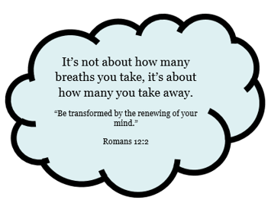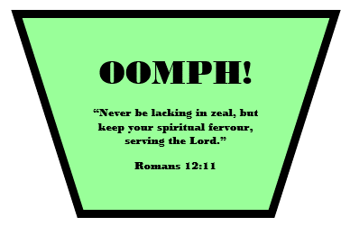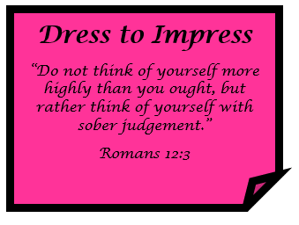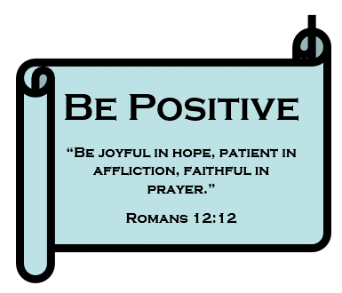

INTRODUCTION
The policy is underpinned by the school’s core value:
‘Every Child Matters, Every Day’

At Queens C of E Academy, we believe that writing is an essential skill that enables children to communicate effectively and express themselves with confidence. Writing is a key part of our curriculum and supports learning in all subjects. We strive to create a culture of high expectations and a love of writing by using a flexible approach to Big Writing developed by Ros Wilson. Through this approach, we build children’s confidence in vocabulary, sentence structure, and writing fluency, underpinned by the VCOP framework (Vocabulary, Connectives, Openers, Punctuation).

Our writing curriculum ensures that children become articulate, creative, and reflective writers, preparing them for future learning and life beyond school.

We aim to develop:
- A love of writing and an appreciation of its power.
- The ability to write for a range of purposes and audiences.
- An understanding of writing as a tool for communication, persuasion, and creativity.
- Competence and confidence in sentence construction, vocabulary choices, and grammatical accuracy.
- A secure understanding of spelling, punctuation, and grammar.
- The ability to edit, refine, and improve writing through structured feedback.
- Stamina, resilience and the ability to write at length

Intent and Rationale
At Queens Church of England Academy, we believe that writing is a crucial skill for all areas of learning. We recognise that children need to develop their writing stamina, confidence, and creativity. Using a flexible approach to Big Writing, we ensure that children are equipped with strong foundations in language and structure and are provided regular opportunities to write at length. The VCOP elements are woven into daily practice and teaching, giving children practical tools to craft quality writing. For each piece of writing, teachers will teach an explicit grammar lesson based on the National Curriculum expectations according to the level of their class based upon analysis on each term from PiXL tests (October, February and June).

The VCOP approach is used to create flair and a passion for writing. The March 2025 interim report of the review of the curriculum and assessment states that the SATs “does not incentivise effective teaching of writing…pupils instead spend considerable time learning to reproduce writing containing contextual features to meet writing assessment criteria, rather than developing fluency in writing.” (page 39) https://assets.publishing.service.gov.uk/media/67d9617b594182179fe08778/Curriculum_and_Assessment_Review_interim_report.pdf

Implementation of Writing Provision
Pupils are provided with a variety of opportunities to develop their writing skills, including:
- Explicit teaching of VCOP strategies.
- Big Writing sessions: extended writing opportunities.
- Shared and modelled writing led by the teacher.
- Writing across the curriculum (e.g., history, science, RE).
- Editing and improving work through structured feedback.
- Handwriting development following a consistent school approach.

Writing units are planned with flexibility. Shorter genres such as instructional texts may be taught and completed within a week, while longer genres such as narratives are delivered over two weeks to allow for depth and development. Teachers are kept up to date with writing subject knowledge and regular CPD for them to have the confidence to be flexible in their approach and when to increase the amount of days for writing and when to remove the amount of days needed to write.

A Typical Writing Week
Across the week, the writing cycle will include:
- Grammar and sentence-level work based on the needs of the genre.
- Vocabulary enrichment through oral and visual stimuli (using the immersive classroom)
- Opportunities for planning and modelled writing with teacher input.
- Big Write sessions where children write independently in response to a stimulus or planned outcome.
Each writing cycle includes an opportunity to edit and improve, either independently or with peer support.

Meeting the Needs of Every Child
We ensure that writing lessons are accessible and challenging for all learners by:
- Providing scaffolds such as word banks, sentence stems, and writing frames.
- Challenging greater depth writers to apply a wider range of language, styles, genres, and perspectives.
- Encouraging discussion and paired talk to help verbalise ideas before writing.
- Offering targeted interventions where appropriate.
- Using a consistent marking and feedback system to help pupils progress.

Impact and Assessment in Writing
Assessment is an ongoing process embedded within daily lessons. Teachers use formative assessment strategies including:
- Pupil discussions and verbal feedback (capturing and correcting misconceptions in the moment of learning)
- Highlighting against writing objectives and success criteria in Big Writing outcomes and independent writing tasks.
- Use of the school’s assessment system to track progress (Insights).
- Moderation across year groups to ensure consistency.

Resources for Writing
To support high-quality writing instruction, we use:
- Big Writing resources and planning frameworks.
- VCOP display materials and toolkits in every classroom.
- High-quality model texts.
- Interactive whiteboards and visualisers to model writing.
- Class reading books and cross-curricular links to inspire writing.
- Dictionaries and thesauruses in every classroom to encourage vocabulary development.
- The immersive classroom for inspiration and stimuli.

Role of the Writing Leader
The Writing Leader is responsible for:
- Ensuring high-quality teaching of writing across the school.
- Supporting staff in implementing Big Writing consistently and effectively.
- Monitoring and evaluating writing provision through lesson observations, work scrutiny, and pupil voice.
- Providing CPD and training opportunities for staff.
- Keeping up to date with curriculum and pedagogical developments.
- Working with SLT to analyse writing data and set targets.
- Using the local authority moderator role to develop and share key pedagogical developments.
- Celebrating writing achievements across the school community.

Parental Involvement
We encourage parents to engage with their child’s writing development by:
- Attending parent-teacher evenings to discuss writing progress.
- Receiving regular updates on writing targets.
- Taking part in workshops and school events.
- Supporting writing at home with practical activities.

Review Date: February 2026
Policy Lead: Writing Lead & English Team
Approved by: Governors

Appendix i: Purpose and audience

- This is the overarching TAF (teacher assessment framework) that underpins how writers will be successful. At the start of every lesson, the purpose of writing needs to be fully explained to children.
- Below is a list of purposes for writing and what genres of writing match these purposes.

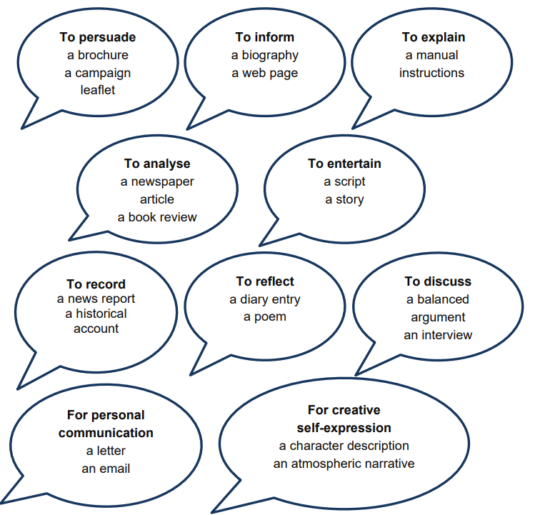

Appendix ii: Teacher handbook for assessment

- Writing no longer needs to be assessed using the writing assessment spreadsheets.
- We are going to be more impactful by assessing children’s work in the moment of learning through live marking and through whole class feedback.
- Writing assessment will look like the following:

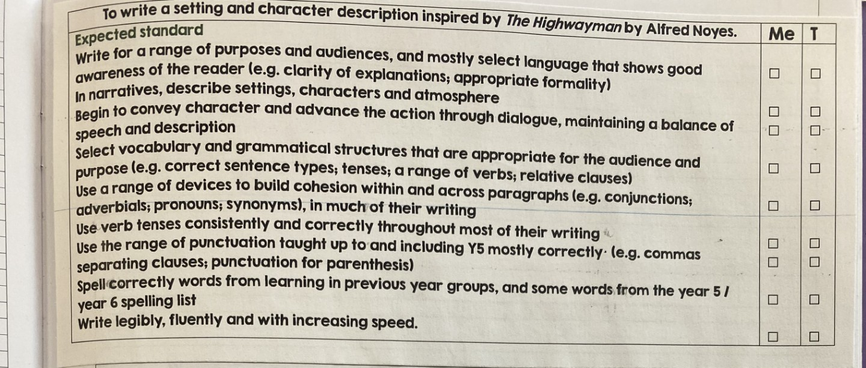

- This is to be stuck in after writing the date.
- Only the expected standards should be stuck in
- Selected children in class could have greater depth standards stuck in their book to indicate that they have a choice to extend writing by using the greater depth statements
- The assessment grid only needs to contain the TAFs and teaching from the National Curriculum for that specific piece of writing.
  - For example – the above assessment grid is for a narrative and therefore does not need the statement that refers to subheadings and headings from non-fiction.
- Please note that children do not need to write a new date in books to show where they got to each day.
- After the whole piece of writing has been completed, children neatly tick the ‘me’ section if they feel they have met the criteria. If they have not, they leave it blank.

Appendix iii: Teacher handbook for marking

- There is no teacher expectation to mark until the first independent writing session is completed
  - There is no expectation to mark word banks for example
  - However, it is vital that teachers are assessing learning during the moment of teaching and learning. This is researched informed and shows how children make the most progress.
  - “Studies of verbal feedback during learning show higher impacts overall (+7 months).” EEF Marking and Feedback Report.
  - E.g. As you are assessing children building model sentences, you may notice during the lesson that they are using too many simple sentences. The class may be stopped and re-taught how to build a complex sentence using an ‘ing’ sentence starter.
- Once a child has completed a piece of writing, the marking will be completed as follows

- The assessment grid is highlighted pink or green accordingly in the ‘t’ (teacher) section.
  - Pink = met the expected standard for that statement
  - Green = met the working towards standard for that statement
- The piece of writing is read, and teachers make a note (in a notebook) of common mistakes that came up in that piece of writing (e.g. tense, incorrect use of dialogue, etc).
- For the final writing session, feedback to children on your notes of common mistakes. Address and re-teach to the class the next lesson accordingly. E.g. Dialogue punctuation was unsuccessful. Re-teach the grammar and edit writing accordingly.
- All edits from a child are to be made in purple pen.
- There is no teacher expectation to make a comment.

