
THRESHOLD CONCEPTS:
DEVELOPING IDEAS, MASTERING TECHNIQUES,
TAKING INSPIRATION FROM THE GREATS
SUBJECT LEADER: Ariadne Makryliotaki
PLANNING COMES FROM: National Curriculum / Chris Quigley “Essentials” (Curriculum Companion)

Whole School Overview
ART AND DESIGN
*As well as the work taught by the specialist art teacher each week, an Art Day occurs once per term.
This supplements the units and skills taught in the discrete art lessons but is delivered by the class teacher.
Year Group | AUTUMN TERMS |  | SPRING TERMS |  | SUMMER TERMS
YEAR 3 | MAP MAKERS! | ADVENTURES OF EARLY MAN | TOMB RAIDERS | LOCATION, LOCATION, LOCATION | FOOD, GLORIOUS FOOD! | ROME AND AWAY!
YEAR 3 | The Renaissance –  artist spotlight: Leonardo da Vinci  AUTUMN ART IN CLASS:  Wrapping paper – printing, natural patterns e.g. holly   |  | Impressionism –  artist spotlight: Pierre-Auguste Renoir  SPRING ART IN CLASS:  Animals / artefacts – Clay  (Ancient Egypt link, History)   |  | Abstract Art –  artist spotlight: Wassily Kandinsky  SUMMER ART IN CLASS:  Roman shields – Collage / Mosaic  (Ancient Romans link, History)  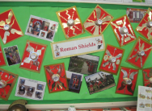
YEAR 4 | THE EARTH STRIKES BACK! | ANGLES AND ANGELS | DRAGON SLAYERS | SHOULD WE SAVE THE RAINFOREST? | WHAT REALLY HAPPENED AT THE BATTLE OF BOSWORTH? | TALES FROM THE RIVERBANK!
YEAR 4 | All work and no play –  artist spotlight: L.S. Lowry  AUTUMN ART IN CLASS:  Collage / Tessellations / Mosaic  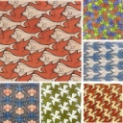 |  | Cityscape Art –  artist spotlight: Camille Pissaro  SPRING ART IN CLASS:  Vikings Digital Art – Befunky photo editor  (Vikings link, History)   |  | Royalty –  artist spotlight: Hans Holbein the Younger and El Greco  SUMMER ART IN CLASS:  Landscape: “A River” – Paint (Watercolours)  (English text link)  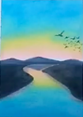
YEAR 5 | OH, I DO LIKE TO BE BESIDE THE SEASIDE! | TOO MUCH OF A GOOD KING? | BRIGHT LIGHTS, BIG CITY | THE MAYA: MASTERPIECE OR MAYA-HEM? | OCEAN COMMOTION! | CHILDREN OF THE REVOLUTION
YEAR 5 | Cultural Tradition in Art –  artist spotlight: Richard Kimbo  AUTUMN ART IN CLASS:  Seasides – Sculpture  (Coasts link, Geography)  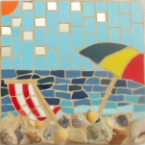 |  | Amazed by Architecture –  artist spotlight: Zaha Hadid  SPRING ART IN CLASS:  Sky scrapers –tesselations and mosaic  (Cities link, Geography)   |  | Exploring Expressionism (Fauvism) –  artist spotlight: Henri Matisse  SUMMER ART IN CLASS:  Flowers and leaves - printing  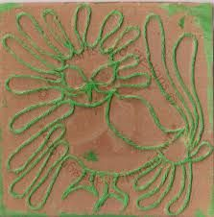
YEAR 6 | GREECE IS THE WORD! | BIOMES AND CLIMATE ZONES 1 | BIOMES AND CLIMATE ZONES 2 | WITHOUT WAR-NING | BRITAIN GOES POP! | REGENERATION ROCKS!
YEAR 6 | Futurism – artist spotlight:  Umberto Boccioni  AUTUMN ART IN CLASS:  Using card to make layers – Sculpture  (Biomes link, Geography)  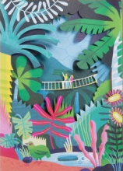 |  | Cultural Tradition in Art –  artist spotlight: Henri Rousseau  SPRING ART IN CLASS:  Capturing conflict, John Piper – watercolour wash and pencils / graphite  (WW2 link, History)  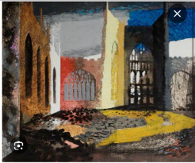 |  | Art and Fashion –  artist spotlight: Piet Mondrian  SUMMER ART IN CLASS:  Pop Art – printing  (Britain since 1945 link, History)  

