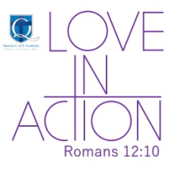
Queens Church of England Academy
Learning and Growing
in the Love of God

Art and Design Policy

Adopted by the Leadership team January 2026
Approved by full Governing Body

Signed by Chair of Governors Paul Allred

To be reviewed January 2028
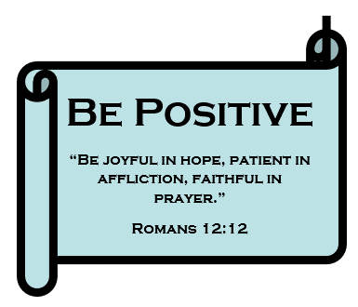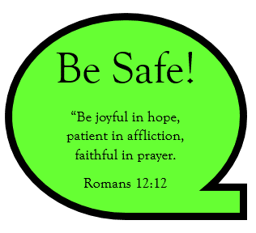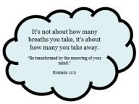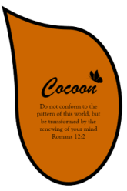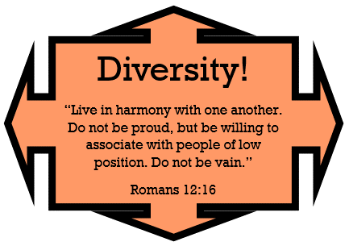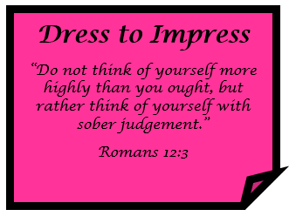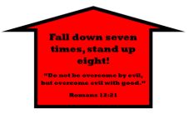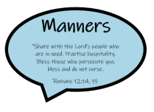

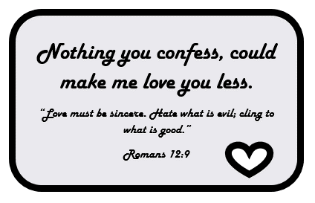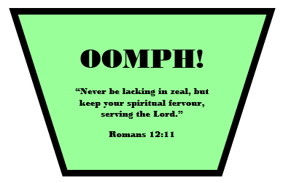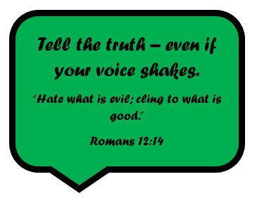

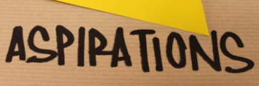

Introduction:

At Queens C of E Academy, we have created an art and design curriculum which we believe will inspire our children to learn more about the world around them, building on what they already know, preparing them for the next steps in their learning, and giving them opportunities to develop the essential skills for life in modern Britain. Based on Chris Quigley’s “Curriculum Companions”, each unit of work studied focuses on the 3 threshold concepts which are: developing ideas, mastering techniques and taking inspiration from the greats. Our art curriculum has been designed and adapted to address the range of skills and media and is linked to our inspirations of Aspirations, Opportunities and Respect.

*This policy should be read in conjunction with the Curriculum policy and with our Teaching and Learning policy.

Aims and Objectives

• To enable children to record from first-hand experience and from imagination, and to select their own ideas to use in their work
• To help each child achieve their creative potential in both two and three dimensional work, working on a variety of scales
• To develop the children’s knowledge of materials by allowing them to experiment freely and to encourage them to use materials sensibly and safely
• To ensure the children learn a range of pertinent skills so that they develop an expertise in using both materials and equipment and so enable the realisation of their ideas
• To explore with children ideas and meanings in the work of artists, craft people and designers and help them learn about their different roles and about the functions of art, craft and design in their own lives and in different times and cultures
• To foster an enjoyment and appreciation of the visual arts and a knowledge of artists, craftspeople and designers
• To encourage pupils to appreciate the beauty, order and precision that is found both naturally and man-made in the world around us.

Key stage 2 (taken from the National Curriculum)

Pupils are taught to develop their techniques, including their control and their use of materials, with creativity, experimentation and an increasing awareness of different kinds of art, craft and design.
Pupils are taught:

1. to create sketch books to record their observations and use them to review and revisit ideas
2. to improve their mastery of art and design techniques, including drawing, painting and sculpture with a range of materials [for example, pencil, charcoal, paint, clay]
3. about great artists, architects and designers in history.

Intent:

We are strong believers in the impact of Art and Design at Queens as part of a broad and balanced curriculum. It provides children with opportunities to develop and extend skills to express their individual interests and ideas, whilst also contributing to the development of the child emotionally, aesthetically, spiritually, intellectually and socially. High quality art education equips children with the skills to explore, experiment, create and invent their own work of art whilst engaging, inspiring and challenging pupils. As artists, children should be able to critically evaluate their work and the work of others, taking influence from well-known artists and adapting their work accordingly. As their skill set progresses, they should understand how art has changed their landscape, culture and history.

Implementation:

Art is taught by a specialist to all classes for the most part. The subject overview shows all of the units covered across the year and also includes discrete art days taught by the class teachers, where longer periods are needed to teach certain skills and content (e.g. use of clay for model making). Half termly overviews map out the sequence of learning in the subject across a given 6/7/8 week period (dependent on the half term’s length), enabling the subject leader and senior leaders to see how any given lesson sits within that sequence of learning.

Pupils are assessed through a variety of formative methods, including ongoing teacher observations, analysis of sketchbook work, and informal discussions during lessons. Opportunities for peer and self-evaluation are embedded within the curriculum, encouraging pupils to reflect on their artistic choices and progress over time.

Planning of the use of the immersive classroom is considered carefully, so as to allow the children a hands-on, kinaesthetic learning experience in as much of the curriculum content as is possible throughout the school. This might be, for example, a virtual tour of an art gallery or museum.

Impact:

At Queens C of E Academy, the impact of our Art and Design curriculum is evident in the high-quality outcomes produced by pupils, their ability to discuss their artistic processes confidently, and their growing appreciation of the role of art in their own lives and the wider world. Through carefully planned progression and specialist teaching, children acquire and embed key artistic knowledge, skills and techniques, enabling them to experiment confidently, refine their ideas, and produce purposeful, expressive work.

Pupils develop resilience, creativity, and independence in their artistic journey, demonstrating pride in their work and a willingness to take creative risks. They can critically evaluate their own pieces and those of others, using appropriate vocabulary and referencing artists studied. Over time, children deepen their understanding of how art reflects and shapes history, culture and identity — locally, nationally and globally.

Assessment outcomes are used to inform future planning and ensure appropriate progression of skills and knowledge. This enables SL to identify individual and cohort strengths, address any gaps in learning, and adapt lesson sequences to support all learners in developing as confident and capable artists.

Ongoing assessment, sketchbook evidence, and pupil voice demonstrate that children across Key Stage 2 make sustained progress and meet age-related expectations in Art. More importantly, they leave primary school with a lifelong appreciation for the value of art, and the confidence to continue exploring and expressing themselves creatively — in line with the aims of the National Curriculum and the Christian ethos of our school.

Roles and Responsibilities

The Art subject leader at Queens C of E Academy is responsible for reviewing the long-term planning for Art annually, ensuring that the curriculum fully aligns with the National Curriculum for Art and Design and reflects the ethos and Christian values of the school. They ensure that pupils have access to a broad and balanced Art curriculum that builds progressive skills in drawing, painting, sculpture, and other artistic techniques across Key Stage 2.

The subject leader regularly monitors teaching and learning through book scrutinies, pupil voice activities, and lesson observations. Findings are recorded in a “Subject Snapshot” and shared with class teachers and the Senior Leadership Team (SLT). Strengths and areas for development are outlined in a termly updated “Subject Status Form.”

They are also responsible for promoting displays of artwork throughout the school, celebrating creativity and raising the profile of Art. The subject leader supports staff with subject knowledge and pedagogy, providing resources or insight where necessary to ensure confidence in delivering Art lessons.

This information is collated by the Head of Curriculum and summarised in the termly “Curriculum Status Form,” which contributes directly to the whole school Self-Improvement and Development Plan (SIDP).

Inclusion and Equal Opportunities

The Art curriculum at Queens C of E Academy is designed to be fully inclusive and accessible to all pupils, including those with SEND and EAL. Lessons are differentiated to meet a range of needs and abilities, ensuring that every child can participate and succeed. The curriculum reflects a wide range of artists, cultures, and artistic traditions, promoting diversity and representation. All pupils are given equitable access to resources, experiences, and opportunities to express themselves creatively.

Health and Safety

Health and safety are prioritised in all Art activities, particularly when working with tools, clay, or other potentially hazardous materials. An Art Risk Assessment is in place, and pupils are taught how to use equipment safely and responsibly. All practical sessions are closely supervised to ensure appropriate behaviour and to maintain a safe, supportive learning environment.

